SAVITRIBAI PHULE PUNE UNIVERSITY

# A PROJECT REPORT ON

**"Predictive Analytics for Infectious Diseases: A Machine Learning Approach"**

**BY**

## Vaishnavi Barasavade(B1910508510) Prachi Sapkal (B1910508559) Shravani Rakate(B1910508552)

Under the Guidance of **Prof. R.M. Samant** In partial fulfillment of

##### S.T.E.S’s

**NBN SINHGAD TECHNICAL INSTITUTES CAMPUS, PUNE-41**

**B.E (INFORMATION TECHNOLOGY)**

## Savitribai Phule Pune University

#### May-June 2024-2025



**NBN SINHGAD TECHNICAL INSTITUTES CAMPUS, PUNE-41 DEPARTMENT OF INFORMATION TECHNOLOGY**

1

**CERTIFICATE**

This is to certify that the Project entitled **"Predictive Analytics for** **Infectious Diseases: A Machine Learning Approach"**

Submitted by

**Vaishnavi Barsavade (B1910508510) Prachi Sapkal(B1910508559) Shravani Rakate(B1910508552)**

Is record of bonafide work carried out by him/her, under my guidance, in partial fulfillment of the requirement for the award of the Degree of Bachelor of Engineering (Information Technology) of Savitribai Phule Pune University

**Date:**

**Place: NBN Sinhgad School Of Engineering, Pune-41**

**Prof. R. M. Samant Prof. R.M. Samant**

**(Internal Guide) Head, Dept. of Information Technology**

**Prof. Dr. Shivprasad. P. Patil External Examiner PRINCIPAL**

### ACKNOWLEDGEMENT

The entire session of partial project completion phase so far was a great experience, providing us with great insight and innovation into learning various software engineering concepts and benefits of any software project, people are the most important assets; our project would not materialize without the cooperation of many of the people involved

We are very much thankful to our respected project guide **Prof. R.M Samant** for his personal involvement and constructive suggestion through the project schedule.He took deep interest in correcting the minor problems and guided as through our journey so far.

We are sincerely thankful to our **(Principle) Dr. Shivprasad. P. Patil** Sir and **(H.O.D) Prof. R.M. Samant Sir** for their valuable recommendation and suggestions

We express our deep gratitude to all staff members of our department and special thanks to **Prof. R.M Samant** for providing us needed help.

Vaishnavi Barsavade(B1910508510) Prachi Sapkal(B1910508559) Shravani Rakate(B1910508552)

### ABSTRACT

Healthcare systems face significant challenges in early disease detection, misdiagnosis, and accessibility, particularly in resource-limited areas. This project proposes a **disease prediction system**

utilizing **Multinomial Naive Bayes (MultinomialNB)** and **Random Forest Classifier** to address these issues. The system analyzes patient symptoms and medical data to predict diseases and provide appropriate remedies, promoting timely interventions and better patient outcomes.

The **Multinomial Naive Bayes** algorithm efficiently handles categorical symptom data through probabilistic modeling, making it well-suited for symptom-based inputs. The **Random Forest Classifier**, employing ensemble learning, enhances the accuracy and robustness of predictions, especially in handling complex datasets and missing data. Together, these algorithms form a reliable and scalable solution designed for real-world healthcare applications.

The system follows a structured methodology: collecting and preprocessing medical datasets, implementing algorithms for disease prediction, and developing a user-friendly interface for patients and healthcare professionals. This interface facilitates symptom input, disease prediction, and remedy suggestions. Model evaluation metrics like accuracy and precision ensure the system's performance and scalability.

Motivated by the need for accessible healthcare, this project aims to reduce diagnostic errors, improve decision-making, and support healthcare providers with data-driven tools. Future extensions include integrating wearable devices for real-time monitoring, telemedicine platforms for remote consultations, and advanced AI techniques like deep learning to enhance prediction capabilities.

By leveraging machine learning, this system addresses critical gaps in healthcare, offering a scalable and efficient solution that enhances diagnostic accuracy, supports early detection, and improves global healthcare accessibility.

**Keywords**

Disease prediction, Multinomial Naive Bayes, Random Forest Classifier, early detection, healthcare accessibility, machine learning, probabilistic modeling, ensemble learning, diagnostic accuracy, patient care, symptom analysis, scalable system, real-world healthcare, telemedicine, wearable devices integration.

Department of Information Technology, NBNSTIC, Ambegaon (Bk.)

## TABLE OF CONTENT

|  |  |  |
| --- | --- | --- |
| CHAPTER NO. | TITLE | PAGE NO. |
| **1.** | **ABSTRACT** | 6 |
| **2.** | **INTRODUCTION**   * 1. Context   2. Purpose of the project   3. Motivation | 7 |
| **3.** | **LITERATION REVIEW** | 9 |
| **4.** | **METHODOLOGY**   * 1. Data Collection   2. Exploratory Data Analysis   3. Feature Selection   4. Model Selection   5. Model Training   6. Model Evaluation   7. Interface Development   8. Deployment and Monitoring   9. Architectural Diagram | 10 |
| **5.** | **CONCLUSION** | 14 |
| **6.** | **REFERENCES** | 15 |

Department of Information Technology, NBNSTIC, Ambegaon (Bk.)

### INTRODUCTION

**1.1 Overview**

The advancement of machine learning and artificial intelligence has opened new avenues for

revolutionizing the healthcare industry, particularly in early disease detection and diagnostic accuracy. This project proposes an advanced **disease prediction system** utilizing **Multinomial Naive Bayes (MultinomialNB)** and **Random Forest Classifier**, two robust machine learning algorithms, to address

critical challenges in modern healthcare. The system is designed to analyze patient-provided symptom data

and associated medical information to predict the likelihood of specific diseases while offering suitable remedies. By focusing on scalability, accuracy, and usability, this solution aims to bridge the gap between medical expertise and accessible, data-driven healthcare services.

At the core of the system lies the **Multinomial Naive Bayes algorithm**, chosen for its efficiency in handling categorical data. This algorithm employs probabilistic modeling to process symptom-based inputs, making it an ideal choice for healthcare datasets characterized by discrete and non-continuous features. In tandem, the **Random Forest Classifier**, a powerful ensemble learning technique, enhances the system's predictive performance by combining the outputs of multiple decision trees. This combination ensures that

the system achieves a high degree of accuracy, robustness against noisy data, and resilience in handling incomplete datasets—a common issue in real-world medical data.

The development pipeline includes a rigorous data preprocessing phase, which involves cleaning, encoding, and managing missing values in large medical datasets. This step ensures that the algorithms

operate on high-quality input data, thereby optimizing predictive performance. The system also features a

user-friendly graphical interface, enabling healthcare professionals and patients to input symptoms and

receive detailed predictions with remedy suggestions seamlessly.

This project aligns with the broader goal of leveraging machine learning to reduce diagnostic errors, facilitate timely medical interventions, and make advanced healthcare tools accessible across diverse geographical and socioeconomic contexts. Future expansion plans include incorporating wearable device data, telemedicine integration, and advanced AI models like deep neural networks to address complex, multi-modal medical datasets. Through these efforts, the project strives to redefine how machine learning can transform modern healthcare.

**1.2 Brief Description**

The **Healthcare Diagnosis and Prediction System** is conceived as an advanced machine learning-driven solution to address critical gaps in modern healthcare, particularly in early disease detection, diagnostic accuracy, and accessibility. The project operates at the intersection of healthcare informatics and artificial intelligence, leveraging state-of-the-art computational methods to process complex medical datasets and

derive actionable insights.

In traditional healthcare systems, diagnostic processes often rely heavily on subjective clinical evaluations and resource-intensive procedures, which can lead to delayed or inaccurate diagnoses. This is further exacerbated in regions with limited access to medical expertise and infrastructure. To mitigate these challenges, this system utilizes **Multinomial Naive Bayes (MultinomialNB)** and **Random Forest Classifier**, two complementary machine learning algorithms optimized for the analysis of medical symptom data and the prediction of disease outcomes.

The **Multinomial Naive Bayes algorithm** is instrumental in handling categorical and probabilistic

data, such as patient symptoms and medical histories. Its lightweight computational requirements make it

ideal for real-time, symptom-based diagnostic systems. The **Random Forest Classifier**, on the other hand, excels in managing complex, high-dimensional datasets through ensemble learning. By aggregating multiple decision trees, it enhances the system's robustness, accuracy, and ability to handle missing or noisy data—common characteristics of real-world healthcare datasets.

The project encompasses a comprehensive pipeline, starting with data acquisition and preprocessing

to ensure input quality and consistency. Key preprocessing steps include feature extraction, data cleaning, encoding of categorical variables, and addressing missing values. The system integrates these algorithms into

a cohesive framework supported by a user-centric interface, allowing healthcare professionals and patients to seamlessly interact with the platform.

The project's broader technological ambition is to establish a scalable, adaptable system capable of integrating advanced features such as wearable device monitoring, telemedicine platforms, and deep learning-based analytics for multi-modal healthcare datasets. By doing so, it aims to redefine healthcare diagnostics

and decision-making, pushing the boundaries of what data-driven medical solutions can achiev.

1.4 Motivation

* **Early Disease Detection**:  
  The increasing prevalence of diseases emphasizes the critical need for systems capable of detecting illnesses at an early stage. Early diagnosis can significantly improve patient outcomes, reduce treatment costs, and prevent complications through timely medical intervention.
* **Reducing Diagnostic Errors**:  
  Misdiagnoses remain a persistent issue in healthcare, leading to delayed treatments and adverse outcomes. This project aims to mitigate these errors by leveraging machine learning algorithms to enhance diagnostic accuracy and reliability.
* **Bridging Healthcare Accessibility Gaps**:  
  In underserved regions with limited access to medical expertise and infrastructure, patients often face barriers to timely and accurate diagnoses. This system offers a scalable, data-driven solution that can democratize healthcare services and reach remote areas.
* **Empowering Healthcare Professionals**:  
  Medical practitioners often need tools that assist in decision-making by analyzing large amounts of patient data. This project provides a system that supports professionals with actionable insights, reducing cognitive load and improving the quality of care.
* **Leveraging Machine Learning for Innovation**:  
  Machine learning algorithms like Multinomial Naive Bayes and Random Forest Classifier are highly effective in handling medical data. By integrating these methods, the project demonstrates how advanced computational techniques can address complex healthcare challenges.
* **Improving Healthcare Outcomes with Scalable Solutions**:  
  Scalable systems that can adapt to various medical scenarios and datasets are essential for improving healthcare outcomes. This project focuses on creating a reliable system capable of handling real-world healthcare data complexities.
* **Cost-Efficiency in Healthcare**:  
  By reducing diagnostic errors and enabling early detection, the system can significantly lower overall healthcare costs, benefiting patients and healthcare providers alike.
* **Promoting Technology-Driven Healthcare Transformation**:  
  This project is motivated by the vision of leveraging technological innovation to transform healthcare delivery, making it more accessible, efficient, and patient-centric.

Department of Information Technology, NBNSTIC, Ambegaon (Bk.)

### LITERATURE REVIEW

Predictive analytics for infectious diseases has become a significant area of research in leveraging data-driven methods to forecast outbreaks and mitigate their impact. Machine learning (ML) models provide robust solutions by processing complex datasets, integrating diverse sources, and producing actionable insights. The following review discusses advancements in this domain based on recent literature. Utilizing Large Language Models and Deep Learning

Shah et al. (2024) developed a predictive framework using large language models (LLMs) and deep learning to anticipate infectious disease outbreaks in India. Their study integrates historical health data, demographic statistics, and climate variables to enhance outbreak forecasting. LLMs play a crucial role in analyzing

unstructured text data such as public health reports, tweets, and articles. The proposed model facilitates

improved decision-making for public health authorities by predicting the temporal and spatial spread of diseases. Systematic Review of Machine Learning Applications

Santangelo et al. (2023) provide a comprehensive review of ML methods, including decision trees, random

forests, and deep learning, for infectious disease prediction. The review synthesizes findings from 75 studies,

demonstrating the wide applicability and high accuracy of ML techniques in forecasting outbreaks. It emphasizes the integration of spatial-temporal data and highlights critical challenges, such as data incompleteness and

interpretability issues, which impact predictive accuracy. Predictive Analytics via Social Media Data

Potnis and Tiple (2023) explore the use of social media platforms like Twitter as a data source for epidemic forecasting. Employing natural language processing (NLP) techniques, their study identifies disease-related keywords and phrases, while sentiment analysis uncovers community-level concerns. These insights are

correlated with real-world epidemiological data to create early warning systems. This approach demonstrates the potential of combining unconventional data sources with ML to enhance public health planning.

Big Data and Multimodal Machine Learning

Chen et al. (2017) propose a CNN-based multimodal approach to predict disease risk using structured and

unstructured data from healthcare systems. By combining patient records, clinical notes, and other hospital data, their model achieves 94.8% accuracy in predicting cerebral infarction risks, significantly outperforming unimodal approaches. The study underlines the importance of integrating multiple data modalities for precise and reliable

forecasting of infectious diseases.

Department of Information Technology, NBNSTIC, Ambegaon (Bk)

### METHODOLOGY

The development of the **Healthcare Diagnosis and Prediction System** follows a structured and technically rigorous approach to ensure its robustness, scalability, and real-world applicability. The methodology is divided into key stages, each addressing critical aspects of the system's design, implementation, and evaluation.

**1. Problem Identification and Requirement Analysis**

* **Healthcare Challenges**: Identify gaps in existing diagnostic systems, such as limited access to resources, high misdiagnosis rates, and delayed treatments.
* **Stakeholder Needs**: Understand the requirements of healthcare professionals and patients, focusing on usability, scalability, and accuracy.
* **Objective Definition**: Define technical objectives, such as integrating machine learning algorithms and ensuring interoperability with healthcare data formats.

**2. Data Collection and Preprocessing**

* **Data Acquisition**: Gather diverse medical datasets, including patient symptoms, disease diagnoses, and treatment records, ensuring comprehensive coverage of diseases and conditions.
* **Data Cleaning**: Address missing values, inconsistent entries, and anomalies using techniques like imputation and outlier detection.
* **Feature Engineering**: Encode categorical data (e.g., symptoms) into numerical formats using methods like one-hot encoding or label encoding. Generate meaningful features that enhance model interpretability.
* **Data Normalization**: Standardize or normalize numerical features to ensure compatibility with machine learning algorithms.

**3. Algorithm Implementation**

* **Multinomial Naive Bayes (MultinomialNB)**:
  + Designed for categorical data, this algorithm applies probabilistic modelling to classify symptoms into likely disease categories.
  + It calculates posterior probabilities using Bayes' theorem, assuming feature independence to simplify computations.
* **Random Forest Classifier**:
  + A robust ensemble learning algorithm that builds multiple decision trees and aggregates their predictions to improve accuracy and reduce overfitting.
  + Handles missing data and complex interactions among features, ensuring resilience against noisy datasets.

**4. System Development**

* **Backend**: Implement data processing and machine learning components using Python libraries such as NumPy, Pandas, and Scikit-learn.
* **Database Integration**: Store patient data, prediction history, and remedy suggestions in a relational database, such as MySQL, ensuring secure and efficient data management.
* **Frontend**: Develop a user-friendly graphical interface using Flask or Django, allowing healthcare professionals and patients to interact with the system for symptom input and disease prediction.

Department of Information Technology, NBNSTIC, Ambegaon (Bk.)

**5. Model Evaluation and Optimization**

* **Evaluation Metrics**: Use precision, recall, F1 score, and accuracy to evaluate model performance on test datasets.
* **Hyperparameter Tuning**: Optimize parameters such as the number of trees in the Random Forest and Laplace smoothing in MultinomialNB to enhance performance.
* **Cross-Validation**: Validate model performance on multiple dataset splits to ensure generalization across unseen data.

**6. Iterative Development and Feedback Integration**

* Adopt an **Iterative SDLC Model**, building the system incrementally.
* Conduct real-world testing with domain experts and refine the system based on feedback regarding usability, accuracy, and relevance.

**7. Deployment and Scalability**

* **Local Deployment**: Begin with local deployment to evaluate performance under controlled conditions.
* **Cloud Integration**: Migrate the system to cloud platforms for broader accessibility, enabling remote access for healthcare providers and patients.
* **Real-Time Processing**: Enable real-time data processing capabilities, integrating wearable devices and IoT sensors for dynamic symptom monitoring.

**8. Future Enhancements**

* Incorporate advanced AI models like deep neural networks for handling more complex medical datasets.
* Expand functionality to include telemedicine integration, multi-disease prediction, and personalized treatment recommendations.

Department of Information Technology, NBNSTIC, Ambegaon (Bk.)

### 4.1 ARCHITECTURE DIAGRAM

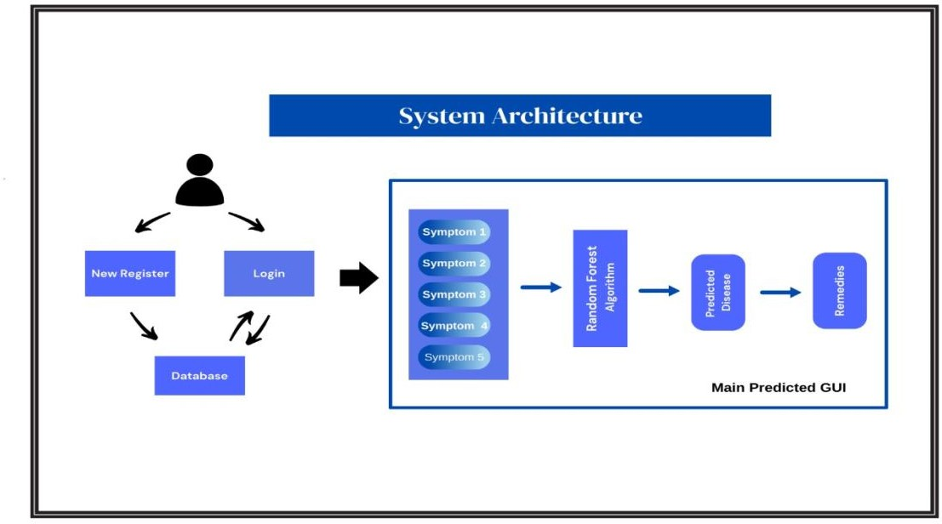

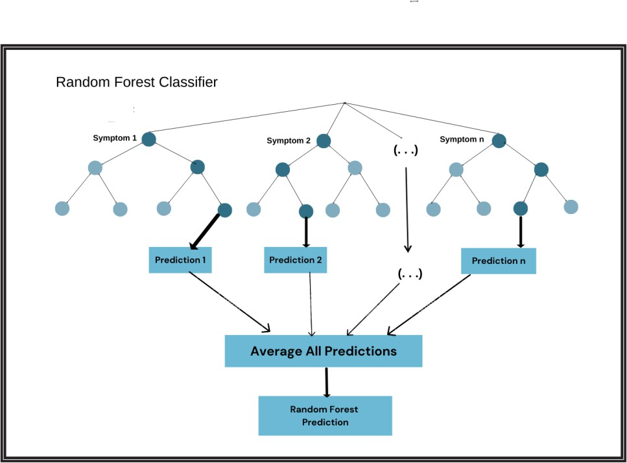

Department of Information Technology, NBNSTIC, Ambegaon (Bk.)

1. **Software Requirement Specification**

This section outlines the various requirements needed for the development, deployment, and use of the healthcare decision support system based on the Random Forest algorithm. These include user, functional, non-functional, technical, hardware/software, and deployment requirements. The goal is to ensure the system is practical, reliable, and easily integrated into clinical workflows.

* + 1. **User Requirements**

The primary users of the system will be healthcare professionals, such as clinicians, doctors, and nurses, who require accurate, real-time decision support based on patient data. The system must provide an intuitive, easy-to-use interface for these users, allowing them to input patient data efficiently and receive actionable insights without technical complexity. Clinicians need to trust the system's recommendations; hence, the output must include clear explanations for predictions, helping users understand the basis of the system’s decisions. This interpretability is crucial for adoption in clinical settings, as clinicians need to justify their decisions to patients and peers. Additionally, IT administrators are secondary users, responsible for maintaining, updating, and securing the system. For them, the system must offer robust security features, such as user authentication, role-based access, and compliance with healthcare regulations like HIPAA. IT administrators also need simple tools for system management, monitoring, and troubleshooting, ensuring that the system runs efficiently within the hospital's IT infrastructure without requiring extensive training or resources.

Clinicians: The primary users will be healthcare professionals, including doctors and nurses. They need an intuitive interface to input patient data and receive actionable insights in real-time. Clinicians also require clear explanations for predictions made by the system to ensure trust in its recommendations.

IT Administrators: Users responsible for managing the system will need a secure, maintainable system that can be easily integrated into existing hospital IT infrastructure. It must comply with data privacy regulations like HIPAA**.**

**5.1.2 Functional Requirements**

The functional requirements outline the core capabilities of the system. First, the system must be able

to collect and process patient data, such as medical history, diagnostic test results, and treatment plans,

through various input formats, including manual data entry and automated integration with hospital

information systems (HIS). Once the data is ingested, the system should leverage the Random Forest

algorithm to provide accurate predictions related to patient outcomes, such as risk assessments or

treatment recommendations. A critical functional requirement is the ability to offer interpretable

Department of Information Technology, NBNSTIC, Ambegaon (Bk.)

outputs—specifically, the system must explain the key features that influenced its decisions. Additionally,

the system must support real-time processing, ensuring that predictions are delivered promptly to assist in

time-sensitive clinical situations. The system must also integrate seamlessly with existing hospital databases

and electronic health records (EHR) via APIs, enabling clinicians to retrieve and input patient data

without workflow disruptions. Finally, the system should have built-in mechanisms for regular updates

and performance monitoring, ensuring continuous improvement and reliability.

* **Data Input**: The system must accept patient data, including medical history, diagnostic results, and

other relevant health metrics.

* **Prediction & Explanation**: The system must provide accurate, interpretable predictions using the

Random Forest model and explain the key factors influencing those predictions.

* **Real-Time Processing**: Predictions must be generated in real-time to support clinical decision-making

without delays.

* **Integration**: The system must integrate with existing hospital databases and workflows through APIs.

**5.1.3 Non-functional Requirements**

Non-functional requirements address performance, security, scalability, and usability. The system

must maintain high availability, ensuring that clinicians can access it at any time, even in high-demand

situations like emergency rooms. Response times should be optimized for real-time decision-making, with

minimal latency during data input and prediction generation. Scalability is another key concern; the system must

be capable of handling increasing volumes of data, such as a growing patient database or more complex

medical records, without compromising performance. Security is paramount, particularly in the context

of healthcare data. The system must comply with data privacy regulations, including HIPAA, and

implement encryption protocols for both data storage and transmission. Role-based access control should

be in place to ensure that only authorized personnel can access sensitive information. Usability is essential for

non-technical healthcare professionals. The interface should be simple and intuitive, with clear visualizations

Department of Information Technology, NBNSTIC, Ambegaon (Bk.)

of data and predictions, requiring minimal training. Additionally, the system must provide a consistent user

experience across devices, whether accessed via desktop, tablet, or mobile.

* **Performance**: The system must offer high availability, with response times suitable for real-time clinical decisions.
* **Scalability**: The system should be scalable to accommodate large datasets and an increasing number of users.
* **Security**: Data encryption, secure communication, and access controls are required to ensure compliance with healthcare regulations.
* **Usability**: The interface should be user-friendly for non-technical healthcare professionals.

**5.1.4 Technical Requirements**

The technical requirements cover the specific programming languages, libraries, and frameworks necessary

for system development. **Python** will be used to implement the Random Forest algorithm due to its powerful

data processing libraries and machine learning frameworks, such as **Scikit-learn** for model training and

evaluation. For data handling and preprocessing, libraries like **Pandas** will be employed to manage

healthcare datasets efficiently. For visualizing model interpretability, libraries such as **Matplotlib** and **Seaborn**

will be utilized to present feature importance charts and other graphical representations of data.

The web-based interface will be developed using the **MERN stack**, consisting of **MongoDB**

(for database management), **Express.js** (as the web server), **React.js** (for the front-end user interface), and

**Node.js** (for back-end server logic). This combination of technologies ensures a flexible, scalable, and user-

friendly system capable of handling both real-time predictions and long-term storage of patient records. The

system must also support APIs for data integration, enabling smooth communication between the decision

support system and hospital information systems (HIS).

* **Programming Languages**: The system will be developed using **Python** for machine learning and

**JavaScript** (React) for the frontend.

* **Libraries**: Scikit-learn for the Random Forest algorithm, Pandas for data handling, and Matplotlib/Seaborn

for visualization.

Department of Information Technology, NBNSTIC, Ambegaon (Bk.)

* **Frameworks**: MERN (MongoDB, Express, React, Node.js) will be used for web development.

**5.1.5 Minimum Hardware and Software Requirements**

The minimum hardware requirements ensure that the system operates efficiently without hardware

limitations. At a minimum, the server should have **8GB of RAM**, which is necessary for handling large

healthcare datasets and running machine learning algorithms in real-time. A **500GB SSD storage** is

recommended to store patient data, model outputs, and other necessary files while ensuring fast

read/write operations. The server should also have **multi-core processors** (preferably with 4 cores or more)

to parallelize data processing tasks and run computationally intensive machine learning models like Random

Forest. In terms of software, the operating system should be either **Linux** or **Windows**, depending on the

hospital’s IT environment. Key software dependencies include **Python 3.x** for machine learning,

**Node.js** for backend services, and **MongoDB** for database management. A modern **web browser** like

Chrome or Firefox is required for clinicians to access the system interface. Additionally, **Docker** containers

can be used to ensure consistency between development, testing, and deployment environments, simplifying

the installation process.

* **Hardware**: A server with at least 8GB RAM, 500GB storage, and multi-core processors for efficient computation.
* **Software**:
* OS: Linux or Windows
* Python 3.x, Node.js, MongoDB
* Web browser for interface access (Chrome, Firefox)

Department of Information Technology, NBNSTIC, Ambegaon (Bk.)

1. **Project Plan**

The project plan outlines the key phases, tasks, resources, and schedules involved in developing the healthcare decision support system. This structured plan will guide the project from inception through to completion, ensuring that milestones are met, resources are properly allocated, and the system is delivered on time.

**6.1 Project Summary**

The project aims to develop an interpretable machine learning-based healthcare decision support

system utilizing the Random Forest algorithm. This system will enhance clinical decision-making by

providing accurate, real-time predictions with clear explanations for each recommendation, ensuring

that healthcare professionals can trust and adopt the tool. The project will include data collection,

model development, system integration, testing, and deployment. The final deliverable will be a fully

integrated system that supports clinicians in making more informed decisions. It will be designed to

handle large healthcare datasets, integrate with existing hospital IT infrastructures, and comply with

relevant data privacy standards like HIPAA.

**6.2 Project Scope**

The scope of the project includes the design, development, and deployment of a machine

learning-based decision support system. The system will be used primarily in clinical settings to provide

real-time support for patient diagnosis and treatment decisions. The project will involve:

* **Data Collection**: Acquiring relevant patient data from hospital information systems and

external sources.

* **Machine Learning Model**: Developing a Random Forest-based predictive model to analyze

healthcare data and offer insights.

* **Integration**: Ensuring the system integrates with existing hospital IT systems and workflows,

allowing clinicians to access and input patient data easily.

Department of Information Technology, NBNSTIC, Ambegaon (Bk.)

* **Interface Development**: Building a user-friendly interface using the MERN stack to allow

healthcare professionals to interact with the system.

* **Testing & Validation**: Validating the system using real-world healthcare data and testing it in a

clinical environment to ensure accuracy, usability, and reliability.

* **Deployment**: Deploying the system either on-premises or in a cloud environment, depending on

hospital infrastructure.

**6.3 Deliverables**

The main deliverables of the project are as follows:

1. **Machine Learning Model**: A Random Forest model trained on healthcare data, optimized for

accuracy and interpretability.

1. **Web Interface**: A MERN stack-based web interface for clinicians to interact with the system,

input data, and receive predictions.

1. **API Integration**: Functional APIs for integration with hospital information systems and

other healthcare databases.

1. **Documentation**: Comprehensive user manuals, technical documentation, and code comments

to facilitate future maintenance and upgrades.

1. **Testing Reports**: Detailed reports on system validation and testing results, including accuracy,

response times, and clinician feedback.

1. **Deployment Plan**: A deployment strategy document detailing how the system can be installed,

updated, and scaled, either on-premises or in the cloud.

**6.4 Resource Allocation**

To ensure the success of the project, resources will be allocated based on specific roles

and responsibilities, each focusing on critical aspects of development and delivery.

Department of Information Technology, NBNSTIC, Ambegaon (Bk.)

**6.4.1 Project Coordinator**

The project coordinator will be responsible for overseeing the entire project lifecycle. This role

includes managing timelines, tracking progress, and ensuring that all tasks are completed within the

specified deadlines. The coordinator will also handle communication between teams and stakeholders,

ensuring that any potential delays or challenges are addressed promptly.

**6.4.2 Quality Assurance**

A dedicated quality assurance (QA) team will focus on testing the system to ensure it meets

all functional and non-functional requirements. QA engineers will be responsible for performing system

testing, unit tests, and integration tests, ensuring that the machine learning model is accurate, the interface

is user-friendly, and the system complies with data privacy standards. The QA team will also

monitor performance and scalability in a simulated clinical environment.

**6.4.3 Documentation**

The documentation team will create all necessary documentation, including user manuals,

technical documentation for developers, and deployment guides. This will ensure that both

end-users (clinicians) and IT administrators have the information they need to use and maintain the

system effectively. The documentation team will also provide guidelines on system updates, error handling,

and troubleshooting.

**6.4.4 Deployment and Infrastructure**

The deployment team will manage the installation and configuration of the system in the chosen

environment (cloud or on-premises). This team will work closely with hospital IT administrators to

ensure smooth integration with existing systems and infrastructure. They will also ensure that the system

meets all security and regulatory requirements during deployment and provide ongoing support post-launch.

Department of Information Technology, NBNSTIC, Ambegaon (Bk.)

**6.4.5 Risk Management**

The risk management team will be tasked with identifying, analyzing, and mitigating potential

risks throughout the project lifecycle. This includes risks related to data privacy, model accuracy,

system performance, and deployment challenges. The team will develop contingency plans for potential

issues such as hardware failure, data breaches, or integration problems, ensuring minimal disruption to

project timelines and outcomes.

**6.4.6 Communications and Plans**

A clear communication plan will be established to ensure that all stakeholders, including

the development team, hospital staff, and project sponsors, are regularly updated on project progress.

Regular meetings, progress reports, and status updates will be shared through collaboration tools. This plan

will also include a feedback loop to incorporate input from clinicians and other end-users during

the development and testing phases to ensure the system meets their needs.

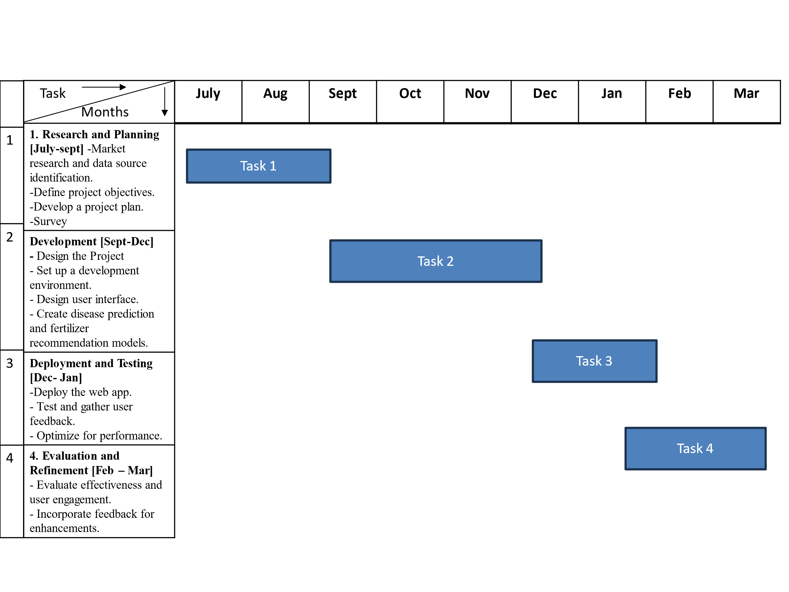

Department of Information Technology, NBNSTIC, Ambegaon (Bk.)

1. **CONCLUSION and FUTURE SCOPE**

**7.1 Conclusion**

The **Healthcare Diagnosis and Prediction System**, powered by **Multinomial Naive Bayes** and **Random Forest Classifier**, addresses some of the most pressing challenges in modern healthcare—early disease detection, diagnostic accuracy, and accessibility. By leveraging machine learning techniques, the project

offers a transformative approach to improving patient care and outcomes, aligning seamlessly with its underlying motivations.

The system fulfills the need for **early disease detection** by accurately analyzing patient symptoms and medical data, enabling timely interventions. Early diagnosis is a critical factor in reducing the progression of diseases and improving survival rates, particularly in cases where delayed treatments can have severe consequences. This directly supports the motivation of enhancing patient outcomes while reducing the burden on healthcare providers.

The use of machine learning algorithms mitigates **diagnostic errors**, a significant issue in conventional healthcare systems. The probabilistic modeling capabilities of Multinomial Naive Bayes efficiently process symptom-based inputs, while the ensemble learning power of the Random Forest Classifier ensures

robustness and precision in handling real-world, noisy datasets. This results in a highly reliable system that minimizes errors and builds confidence among healthcare professionals and patients.

By addressing **healthcare accessibility**, the project serves regions with limited medical resources.

The system’s scalability ensures its adaptability across different healthcare environments, from local clinics to large hospitals. Its ability to integrate with future technologies, such as wearable devices and telemedicine platforms, extends its reach to underserved populations, fulfilling the motivation to democratize healthcare services.

Furthermore, the project promotes **technology-driven innovation** in healthcare, showcasing how machine learning can revolutionize diagnostics. It provides a cost-effective, scalable, and user-friendly

solution, significantly reducing the financial and operational challenges faced by healthcare providers.

In conclusion, this system not only justifies its motivations but also lays a strong foundation for future advancements in healthcare, driving innovation to create a more equitable, efficient, and patient-centric

medical ecosystem.

Department of Information Technology, NBNSTIC, Ambegaon (Bk.)

**7.2 Future Scope**

* **Integration with Wearable Devices**:
* Real-time health data from wearable devices, such as heart rate monitors, blood pressure sensors, and fitness trackers, can be integrated to provide continuous monitoring and enhance prediction accuracy.
* Alerts for abnormal health patterns can facilitate early interventions.
* **Multi-Disease Prediction**:
* Expand the system’s capabilities to predict a wider range of diseases by incorporating larger, more diverse datasets and additional features such as genetic predispositions and environmental factors.
* **Advanced AI and Deep Learning Models**:
* Incorporate deep learning techniques, such as Convolutional Neural Networks (CNNs) and Recurrent Neural Networks (RNNs), to handle complex, multi-modal data, including medical images, genetic sequences, and time-series health records.
* **Mobile Application Development**:
* Develop a cross-platform mobile application to make the system more accessible to end-users. Patients can input symptoms, receive predictions, and access remedies directly from their smartphones.
* **Telemedicine Integration**:
* Integrate the system with telemedicine platforms to facilitate remote consultations. This would allow healthcare providers to access patient data, analyze predictions, and offer treatment recommendations in real time.
* **Personalized Treatment Plans**:
* Incorporate patient history, lifestyle data, and genetic information to offer tailored treatment recommendations and prevention strategies. Personalized care ensures higher efficacy and patient satisfaction.
* **Global Adaptation and Localization**:
* Adapt the system for global use by incorporating region-specific datasets, accounting for geographical, cultural, and epidemiological variations in healthcare needs.
* **Interoperability with Existing Healthcare Systems**:
* Enable seamless integration with electronic health records (EHR) systems and hospital management software, improving workflow efficiency and data exchange.
* **AI-Driven Predictive Analytics**:
* Use predictive analytics to forecast disease outbreaks and trends, assisting public health organizations in implementing preventive measures.

1. **REFERENCES**

##### "Machine Learning and Prediction of Infectious Diseases: A Systematic Review" –

This review examines how machine learning algorithms can predict infectious disease outbreaks,

highlighting the integration of epidemiological data and medical informatics. It explores challenges like data quality and opportunities for using ML to inform public health strategies.

##### "The Predictive Power of Data: Machine Learning Analysis for COVID-19 Outcomes" –

This study focuses on applying ML models to predict COVID-19 severity and mortality based

on clinical and demographic data. It demonstrates how advanced analytics can guide pandemic response and resource allocation.

##### "Deep Learning Techniques for Detection and Prediction of Pandemic Outbreaks" –

This article reviews the use of deep learning to detect and predict infectious disease trends. It provides examples of tools developed for pandemic management and disease spread forecasting.

**"Machine Learning for Clinical Decision Support in Infectious Diseases"** - A narrative review on how ML supports clinical decisions in managing infectious diseases, such as diagnosis and treatment

optimization. It emphasizes the role of big data and computational advances in healthcare settings.

##### "A Comprehensive Analysis of AI in Pandemic Prediction" –

This analysis investigates the use of AI, including machine learning, for real-time prediction of infectious disease hotspots. It discusses predictive modeling's role in mitigating disease impact through early intervention.

Department of Information Technology, NBNSTIC, Ambegaon (Bk.)

### 